Li Cai Haney and Elizabeth Love
30 November 2021
Sports Analytics
Data Analysis Project
Trends in NBA Drafting with Regards to Age and College Experience
Purpose: The purpose of this project was to observe and draw conclusions from NBA drafting data regarding player age, college experience, and draft round and analyze how those things were related to player career and performance.

Data Collection: Player statistics were drawn from basketballreference.com and sports-reference.com. Data was collected for every player from the 2001 to the 2020 NBA draft. A total of 1191 rows of player data was collected. The data collected for each player included age as of February 1 of the NBA season, whether they played in college and for how long, whether they played in their first NBA season, if they were a domestic or international player, and how long they played in the NBA. Based on the team who drafted the player and the team the player was on for their first season, trades were determined. Player performance metrics were collected (Position, Games, Goals Scored, Minutes Played, Field Goals, Field Goal Attempts, Field Goal %, Three Pointers, Three Point Attempts, Three Point %, Two Pointers, Two Point Attempts, Two Point Percentage, effective Field Goal %, Free Throws, Free Throw Attempts, Free Throw %, Offensive Rebounds, Defensive Rebounds, Total Rebounds, Assists, Steals, Blocks, Turnovers, Personal Fouls, and Points Scored) for their last year in college or in another league (for international players) and for the first year after their draft.
Methods: Raw data was broken down for each year, ascertaining the average number of seasons played, the number of seasons since the draft, the overall average age for players, the number of “Prep to Pros” (i.e. domestic players who either played for an international pro league or trained on their own before being drafted rather than play for college) that were picked, the average number of years of college with and without international players included, the number of players who played in the NBA, the number of players who were drafted but never played in the NBA, the average age of international players and average age of domestic players, the number of players traded, the average age of first round picks, and the average age of second round picks. Microsoft BI, Excel, and R were used to create graphs to look at the data.

Findings: Overall, the average age of drafted players is falling. In the 2002 draft, the average age was 21.8 years old, but in the 2020 draft, the average age decreased by more than a year (20.6 years old). International players tend to be younger, on average, than domestic players, with the exception of the draftees of 2017. The proportion of 19 and 20 year old players each draft has been on the rise since 2014 with over 50% of the 2020 draft picks being 19 or 20 years old.

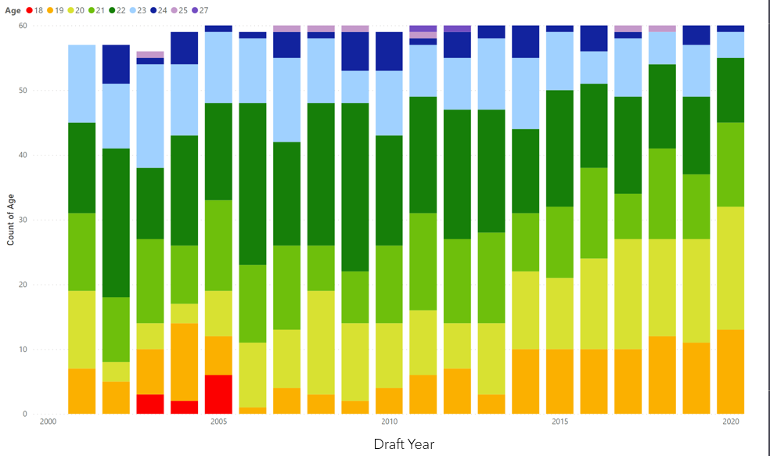
Second round picks tend to be older on average than first round picks with the exception of the 2005 draft. First round picks tend to 19 and 20 year old players while second year players tend to be 20 and 21 year old players, though there seems to be an increase in 19 year old second round picks.

Since 2017, there has been a significant decrease in the number of international players picked since 2017. In that time, there has also been a decrease in the number of players who did not play in their first year, or who never played in the NBA. These two things may be related to one another, as, of the international players that are drafted, only a small portion of them end up playing for their drafted team; many are traded, play in a later season, or never play in the NBA whatsoever. In every draft year, close to half or more of the international players either never played in the NBA or played in a later year. Managers may have decided that international players were simply not worth the use of a draft pick. On the other hand, this may be an effect of Donald Trump’s “Muslim Ban,” enacted in 2017; many Muslim athletes, regardless of whether they were from the affected countries or not, felt alienated. It also complicated the process of drafting for those with dual citizenship, which, as a practical matter, discouraged athletes from attempting to be drafted. If this truly is the reason for the decrease in international athletes, there may be an increase in international athletes now that the ban has been lifted by President Biden. It could also be due to more international players playing in NCAA Division I basketball; international players for this study was defined as being born outside of the U.S. and not playing at a NCAA college program; therefore, players who were born overseas but came to the U.S. and played in college were not included as “international” for this study. The 2021 draft picks included players like Franz Wagner, Kai Jones, Chris Duarte, Joel Ayayi, and Yves Pons who are technically international players, but because they played in a Division I college program, they were not classified as “international”.
Further investigation could look at trends of the number of international players who play Division I basketball before entering the draft.

There has also been an increase in traded players since 2006. The number of draft picks who do not play their first NBA season has also been decreasing over the last three years and the number of drafted players who never play have also been decreasing since 2016. The increase in trades, the ability to send players to the G League part time, and the decrease in international players who originally played overseas and may have a contract with an existing league or feel more comfortable overseas could all be reasons for the decrease in drafted players who are not utilized.
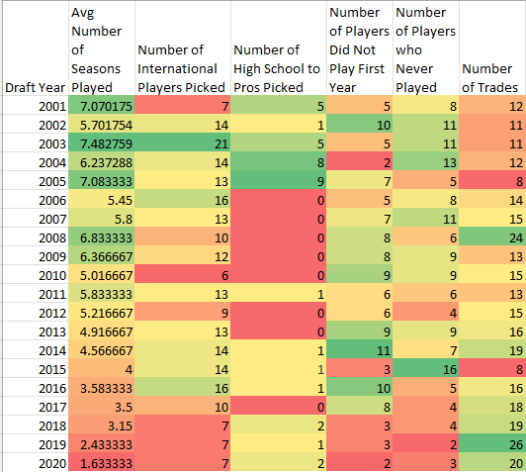
The average number of college years for domestic players has been decreasing since 2013. Before 2016, draft picks averaged at least 2.5 years of college, but in the 2020 draft, the average number of college years draft picks had played was 2.05 years.

The average years of college for drafted players is between two and three years of college experience, and as one goes farther and farther down the draft order, the amount of fourth year and no college players tends to increase, while the amount of one year college players becomes less frequent. There are still a decent number of two and three college year players in the second round draft that is mostly zero and four college year players. One college year players (one and done) tend to be taken in the first round pick with 13/20 first picks from 2001-2020 being one and done players. One and two college year players seem to be favored in the first round of the NBA while the zero year players tend to be international players who are taken in the second round.
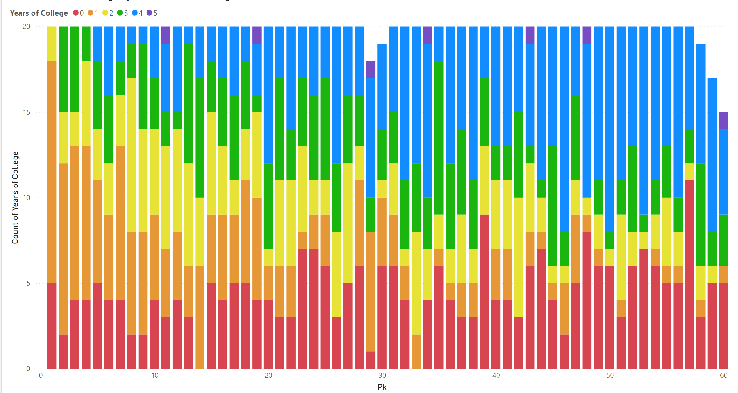
The number of one and done players has increased since 2014, with zero, one, and two college year players making up at least half the draft picks since 2017.
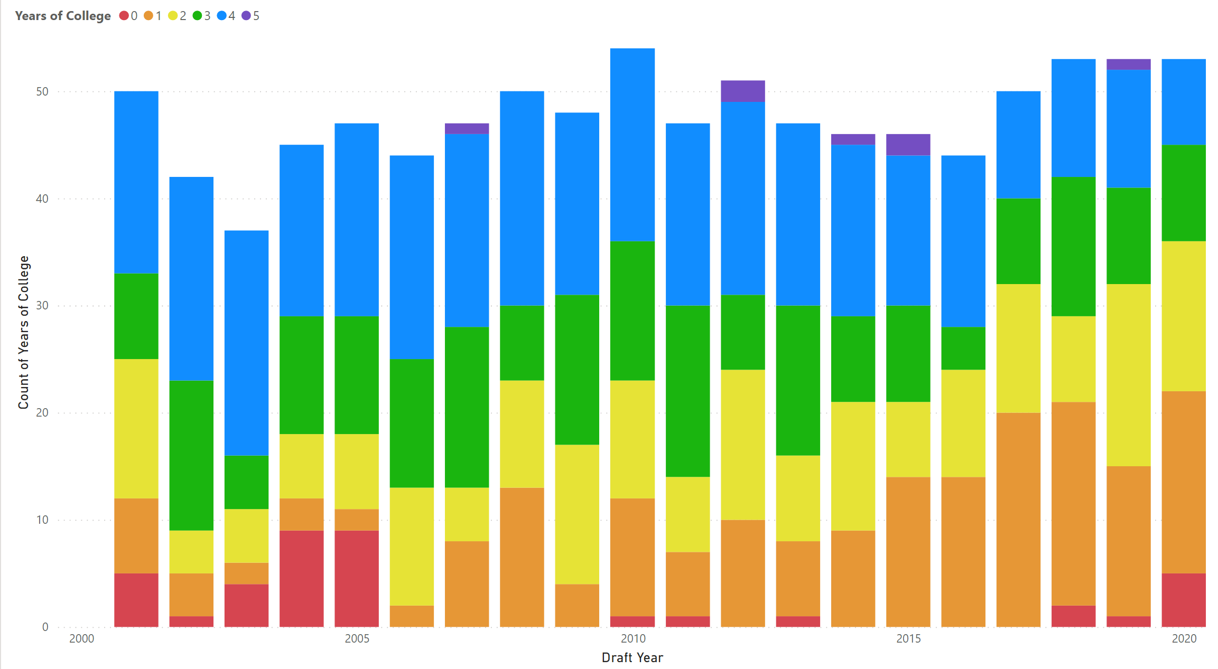

First round picks tended to score more points per minutes played (slope indicates 0.6373 points/minute) than second round picks (slope indicates 0.5707 points/minute). First round picks also scored higher in their first NBA season, but the difference in slope increased to more than 0.1 points/minute (0.4603 points/minute vs 0.3579 points/minute).
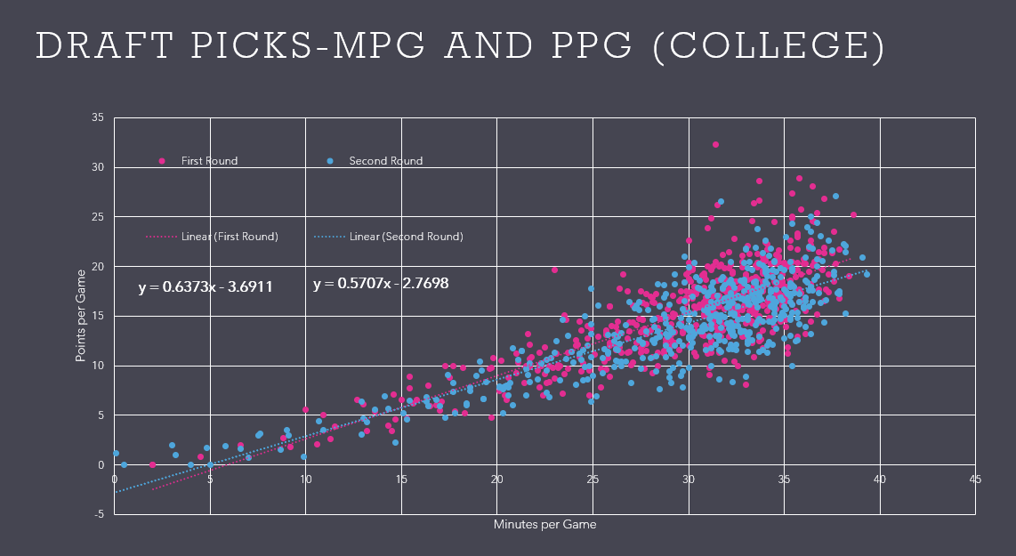
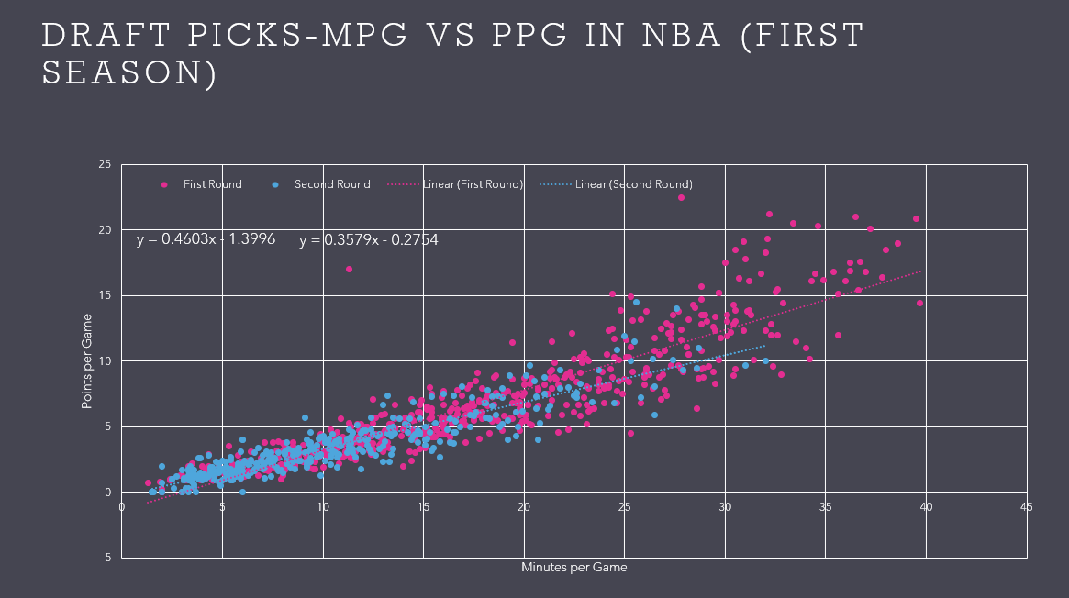
While the average minutes played per game increased by age in college basketball, it decreased by age in the NBA, which is likely due to the fact that second round draft picks, who tend to play for less time, tend to be older. In college, these older players provided leadership and experience, so they would have the opportunity to play more minutes. In the first NBA season, 19 and 20 year old draft picks played more minutes per game than older and younger players.
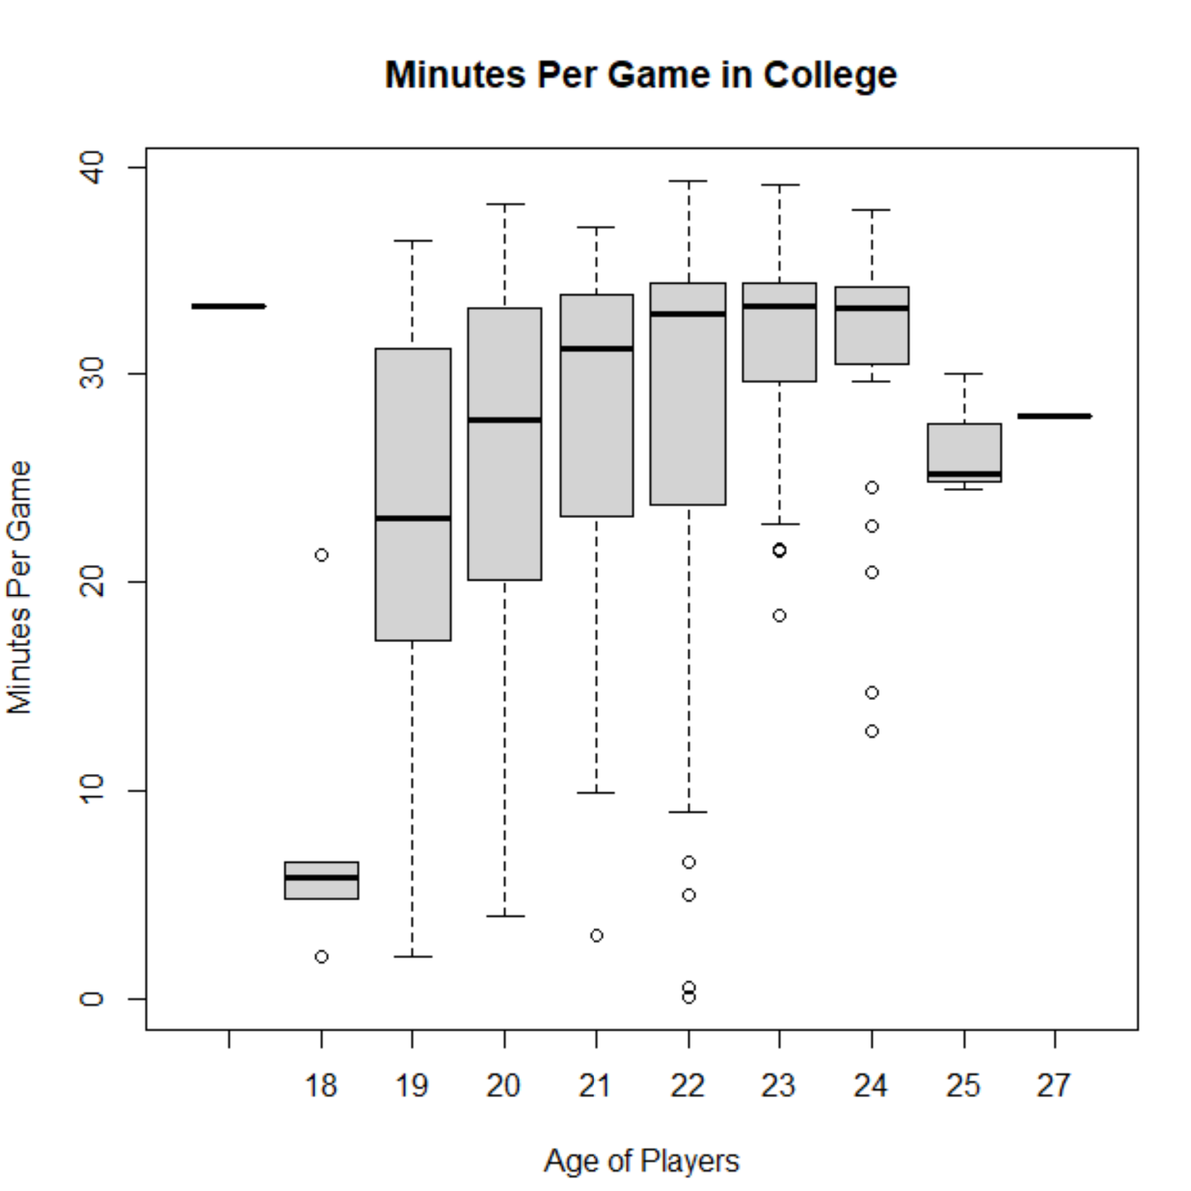
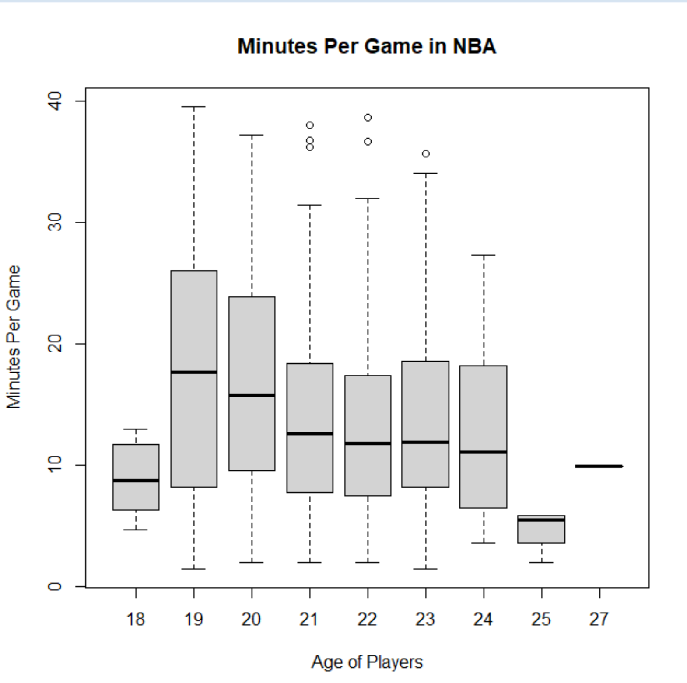
That having been said, the number of years of college had very little effect on the average number of minutes played in the first season of NBA (<5 minute difference).
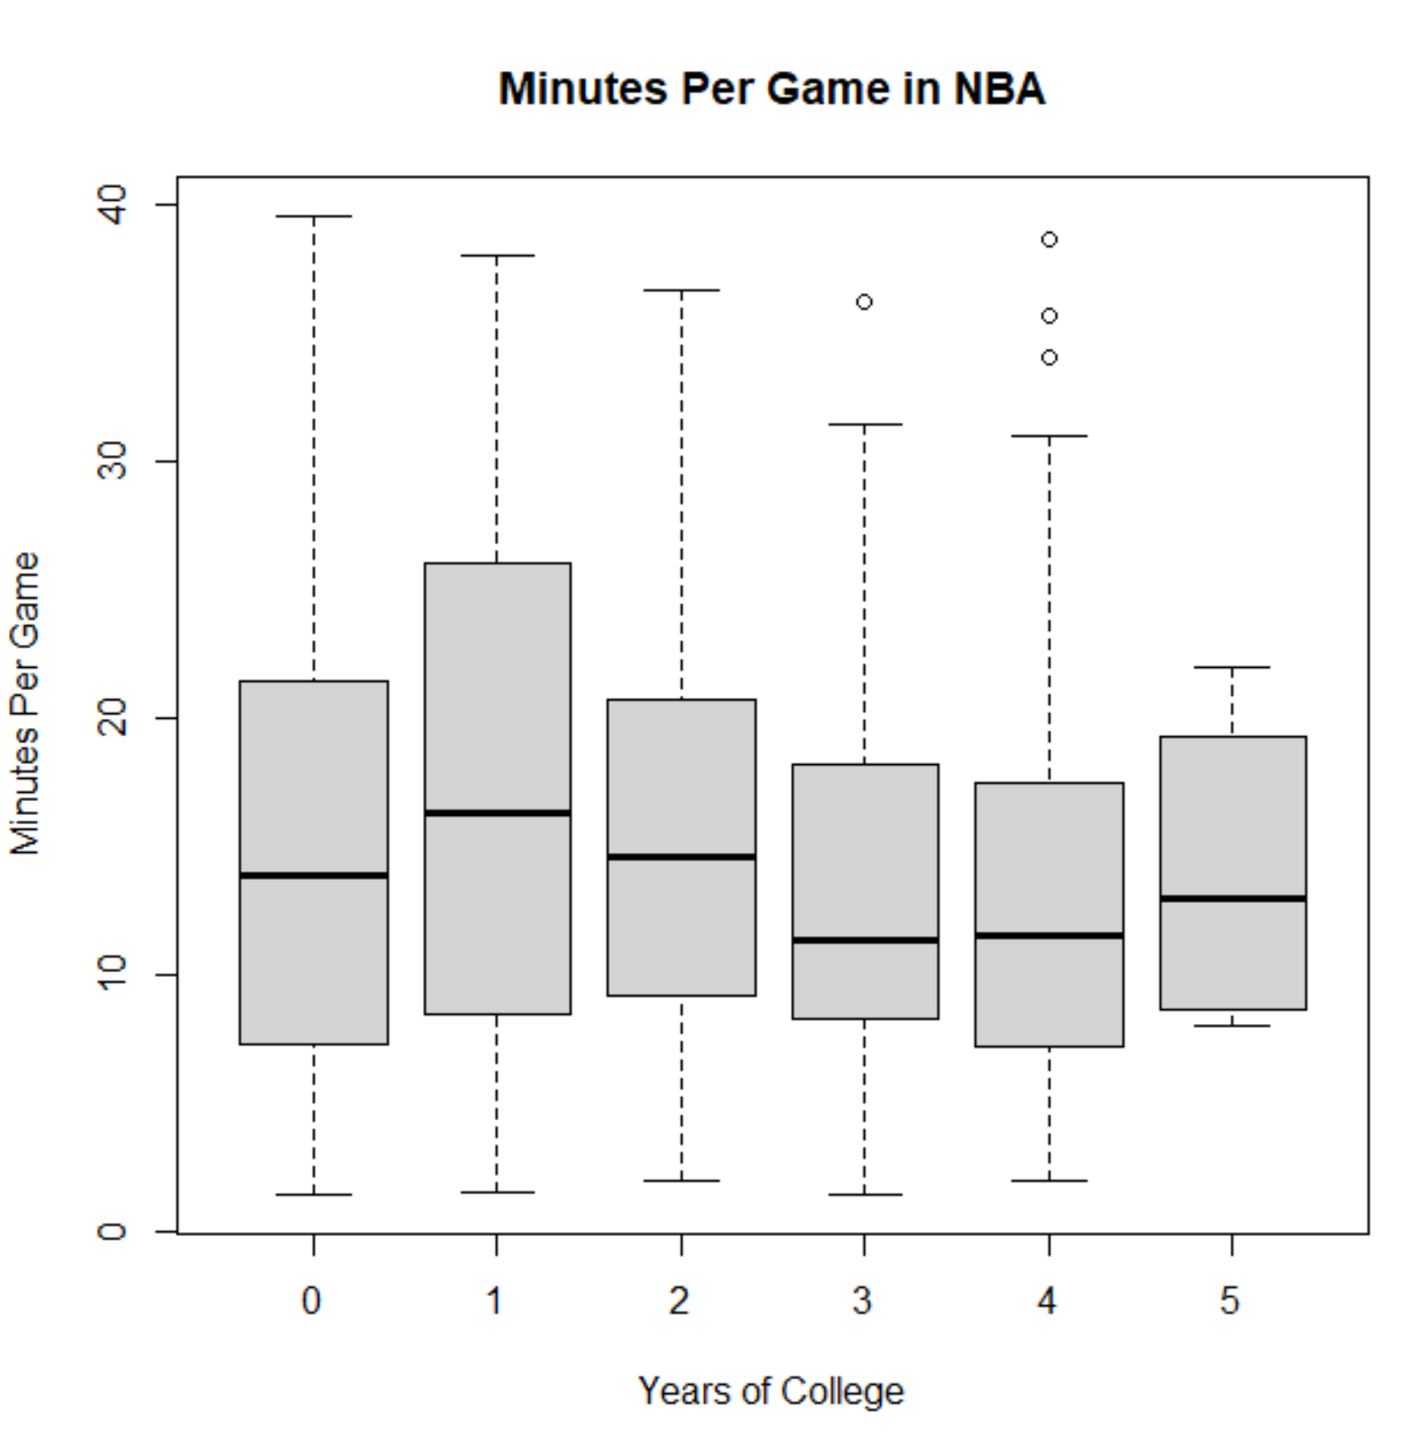
Similarly, there was a relatively small difference in average points per game and number of seasons an athlete would play based on years of college. There did tend to be more one and done players who would average higher points per game than other players that made the 1 college year average higher as well as the decrease in minutes played per game for ≥2 college year players which also decreases how many points per game these players can earn; therefore, the <5 points per game difference in average between one college year players and the others indicates older players can be as valuable as younger players for the time given to them.
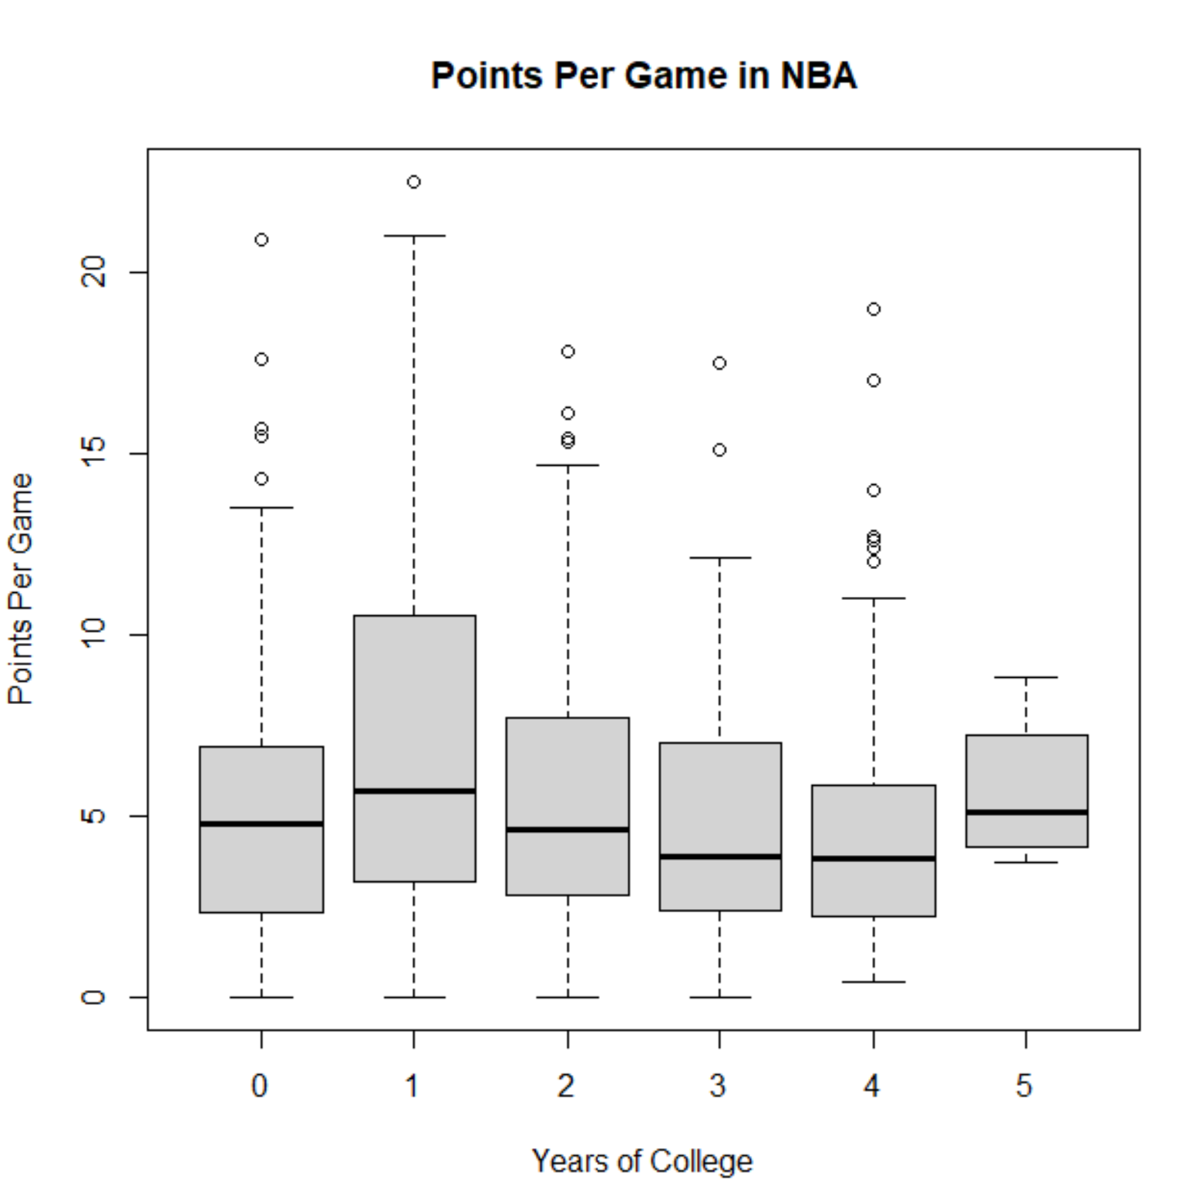
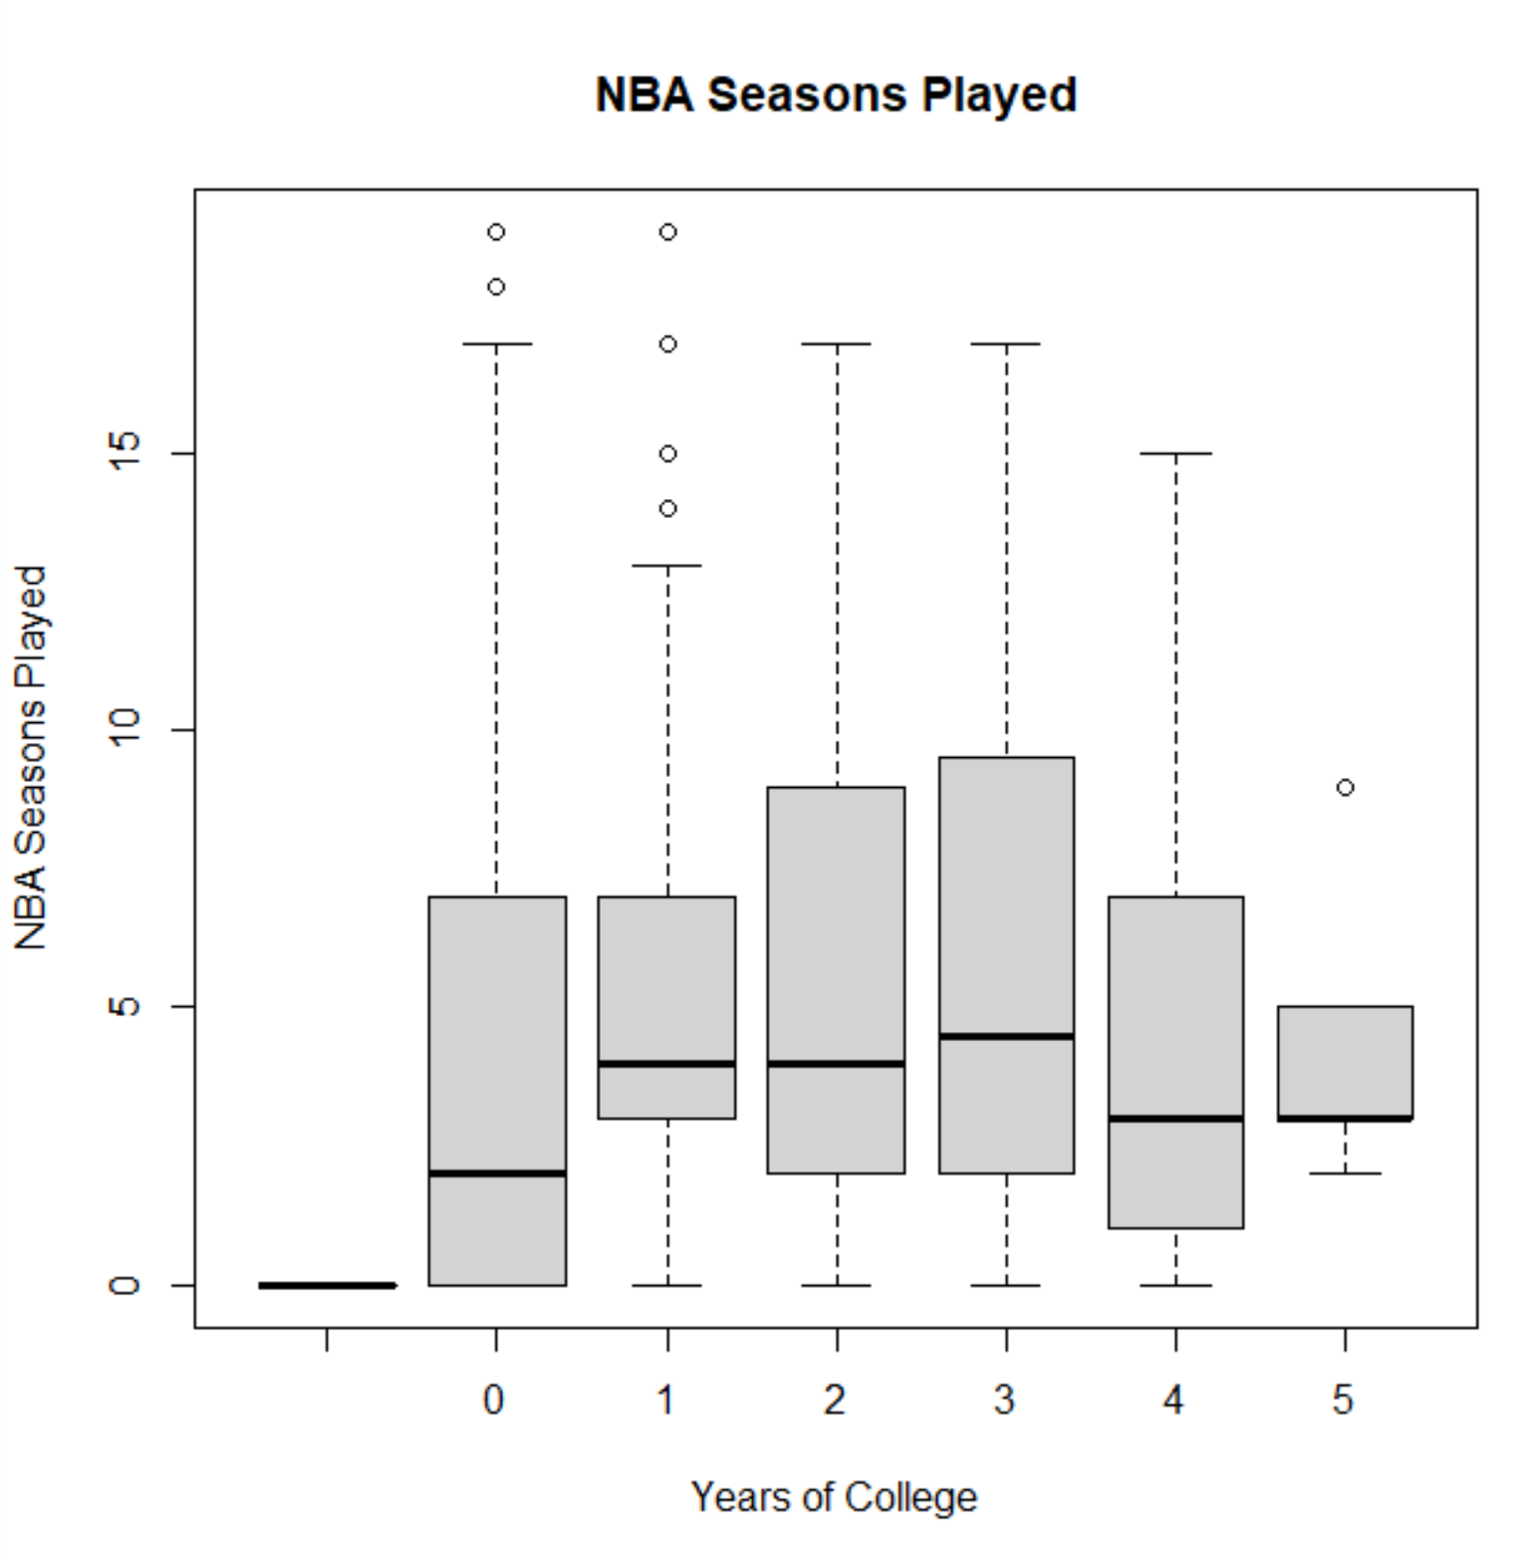

While there are some younger, one or two college year players who do great their first NBA season, on average, there is not much of a difference in terms of average performance of players based on college experience. One and done players do tend to play more minutes per game and earn more points per game compared to the other drafted players, but the difference becomes smaller among ≥2 college year players. A decent number of second round draft picks are two and three college year players. With the ability of college athletes to earn money in college with NIL, there could be an increase in average age and number of years of college of NBA draft picks. For second round one, two, and three college year players, there is now incentive to stay in college an extra year or two to gain more recognition and experience for a higher draft number. First round draft picks tend to have higher earning contracts and perform better their first NBA season. There is a fairly small difference in points per game between ≥2 college year players even with the decrease in minutes per game, so performance wise, older players do bring value to the NBA their first season.

Longman, Jere. “Trump’s Immigration Order Could Have a Big Impact On Sports.” New York Times, 28 January 2017, https://www.nytimes.com/2017/01/28/sports/trump-refugee-ban.html.

